For outputting condional element, we can put them inside the render function as a mutable variable. We can use a state Boolean variable to keep track of the condition, and use it to show/hide the element. We can also do it with ternary expression, but it’s not clean code usually. Better approach is creating variables.

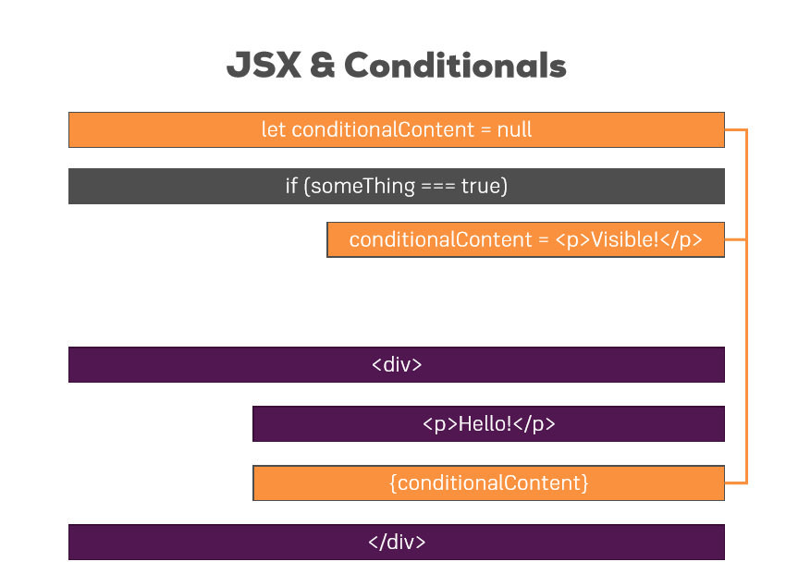

* **Important:** We should always change the state in immutable fashion, without mutating the original state first. For this, we need to make a copy of the state, change that copy and then update the state with setstate.
* **Key Property:** This is a default property of every element that react expects to find on any element (can be custom component or html element). This is unique identifier. Usually if we get data from database, they have unique id. We can use them for the key property.
* We can use map() function to pull single elements from an array/object etc. It also have an index property which we can take advantage of.